Cleaned the JSON file as rows separated by a new line character.

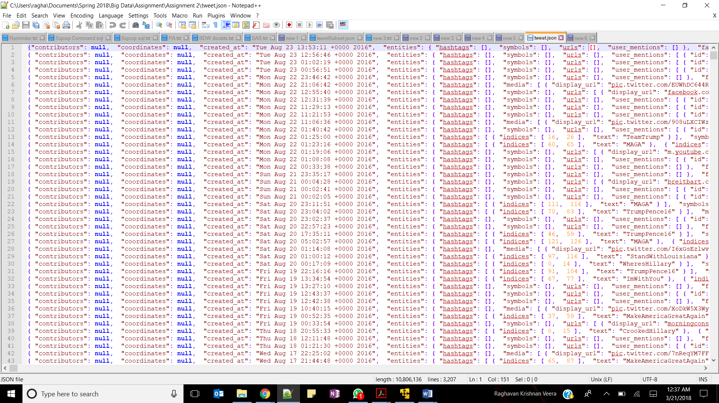

Added the SerDe into hive environment.

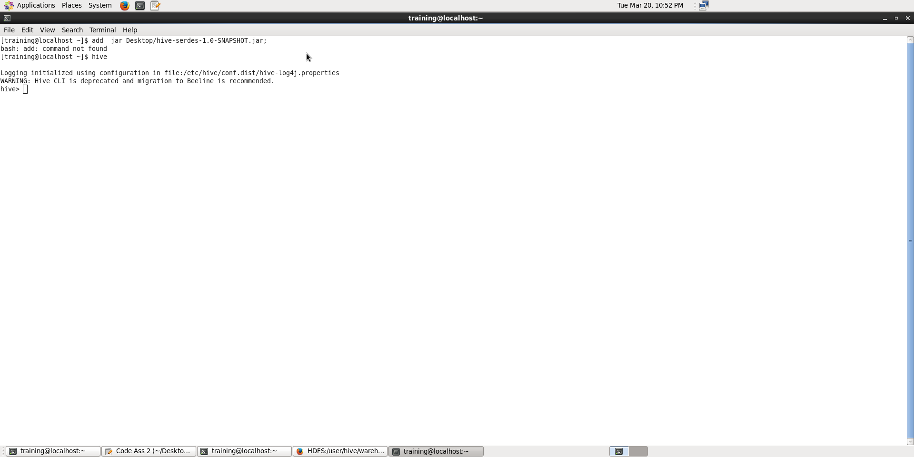

CREATE TABLE tweets_json (

id BIGINT,

created_at STRING,

source STRING,

favorited BOOLEAN,

retweeted_status STRUCT<

text:STRING,

user:STRUCT<screen_name:STRING,name:STRING>,

retweet_count:INT>,

entities STRUCT<

urls:ARRAY<STRUCT<expanded_url:STRING>>,

user_mentions:ARRAY<STRUCT<screen_name:STRING,name:STRING>>,

hashtags:ARRAY<STRUCT<text:STRING>>>,

place STRUCT<

country_code:STRING,

full_name:STRING>,

retweet_count STRING,

text STRING,

user STRUCT<

screen_name:STRING,

name:STRING,

id:int,

friends_count:INT,

followers_count:INT,

location:STRING,

statuses_count:INT,

verified:BOOLEAN,

utc_offset:INT,

time_zone:STRING>,

in_reply_to_screen_name STRING

)

ROW FORMAT SERDE 'com.cloudera.hive.serde.JSONSerDe';

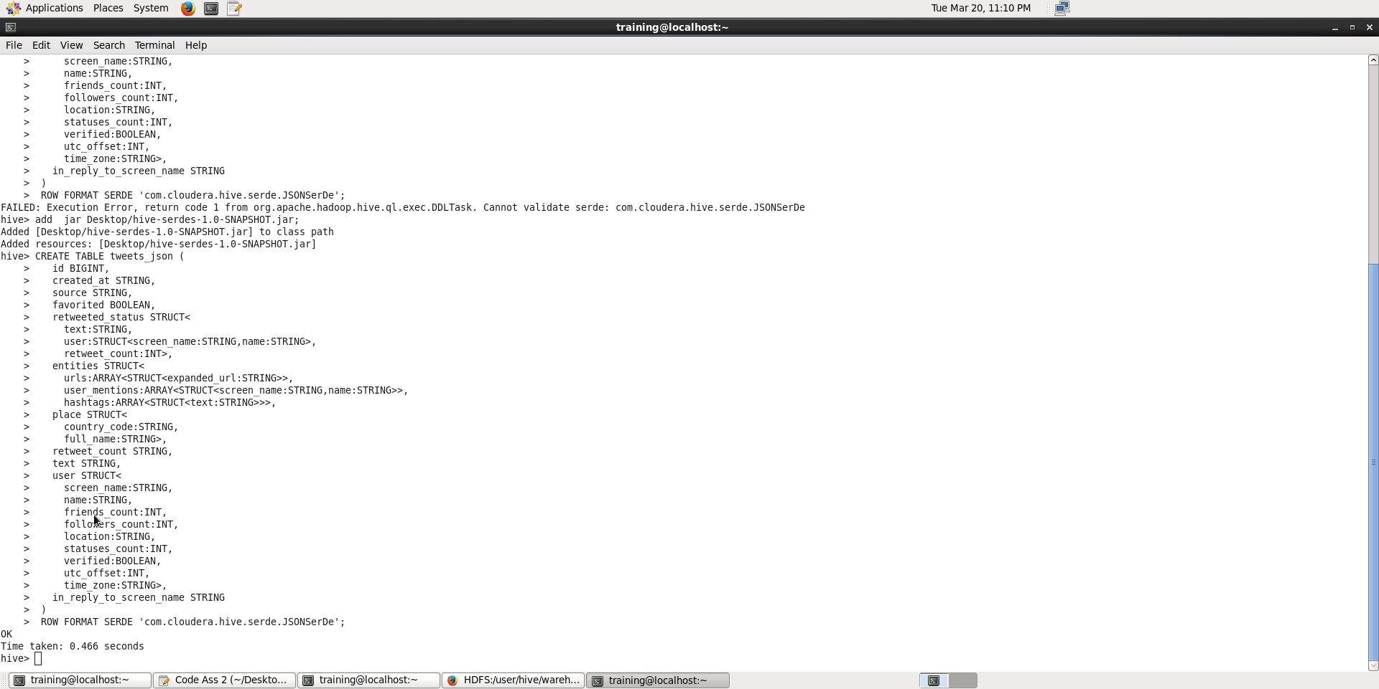

load data local inpath 'Desktop/tweet.json' overwrite into table tweets_json;

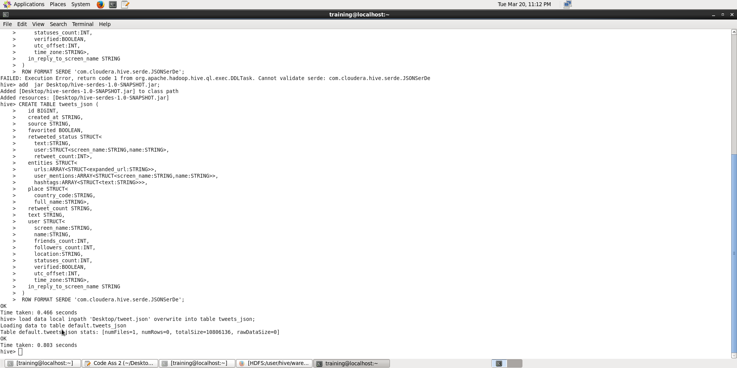

1. A. create table hashtag as select entities.hashtags.text as words from tweets_json;

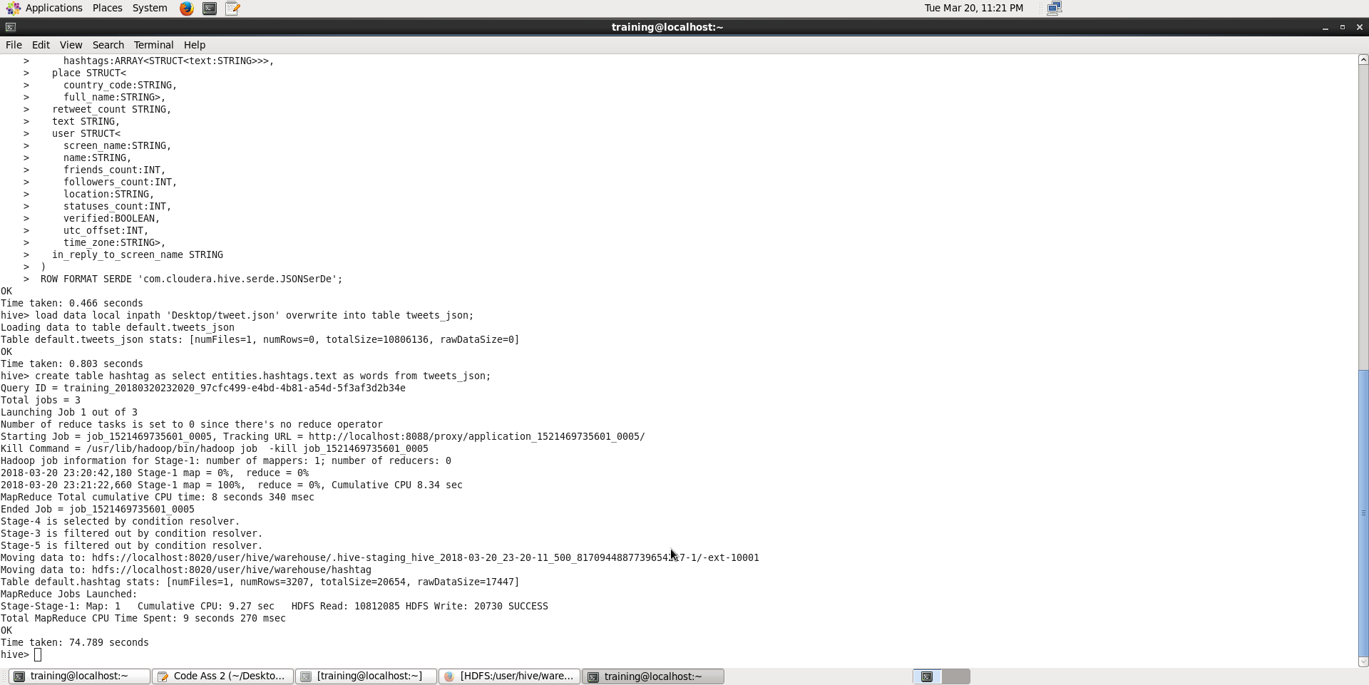

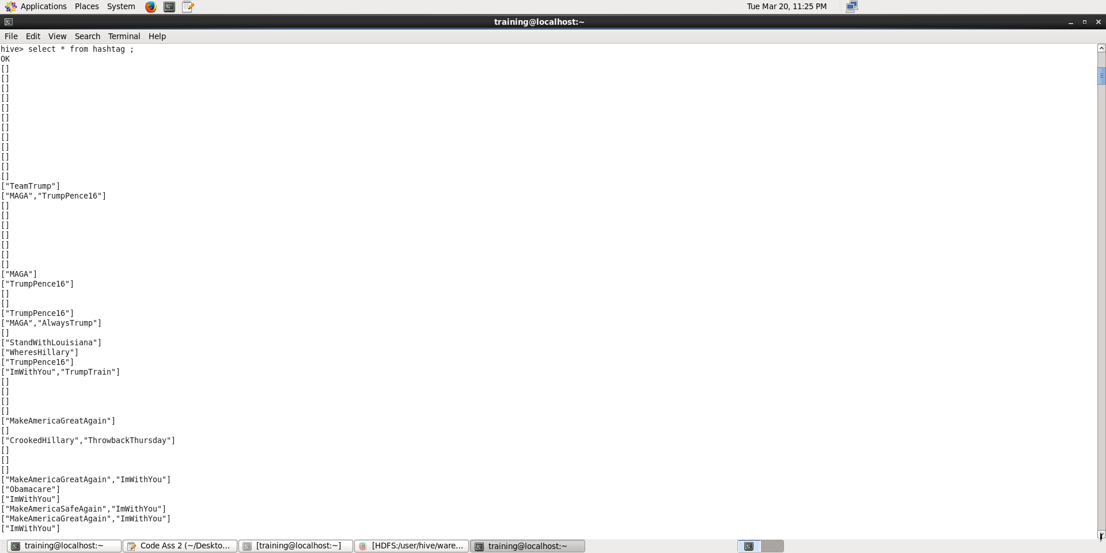

Create table hashtag_split as select explode(words) from hashtag;

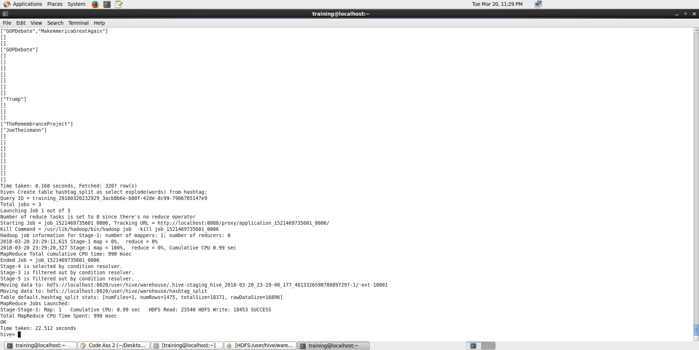

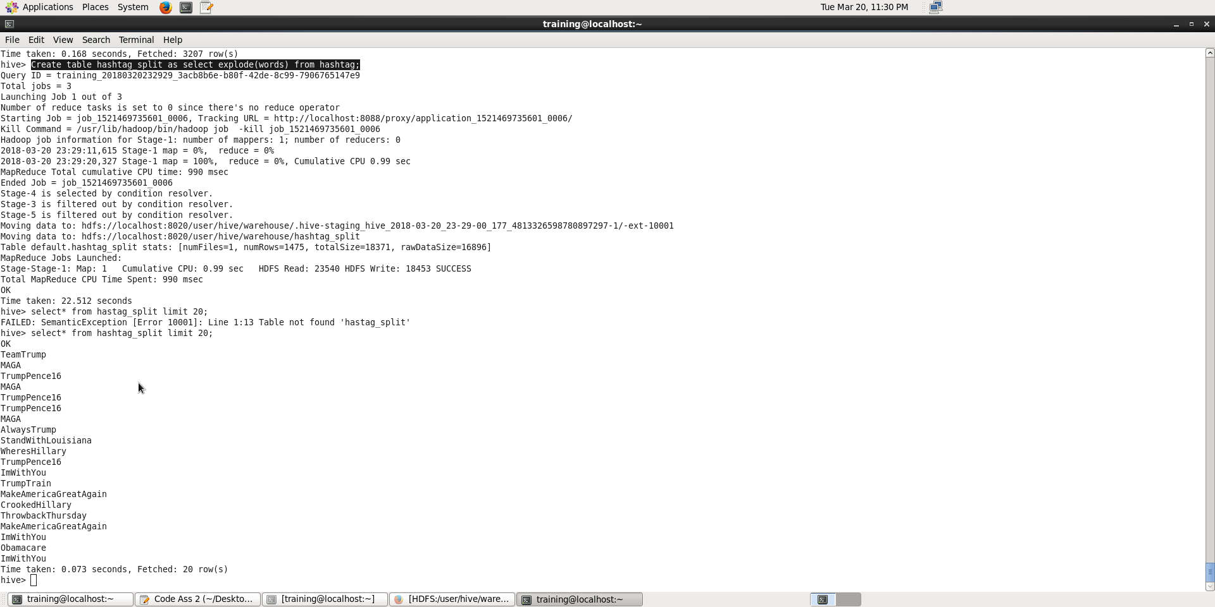

select col, count(col) from hashtag_split group by col;

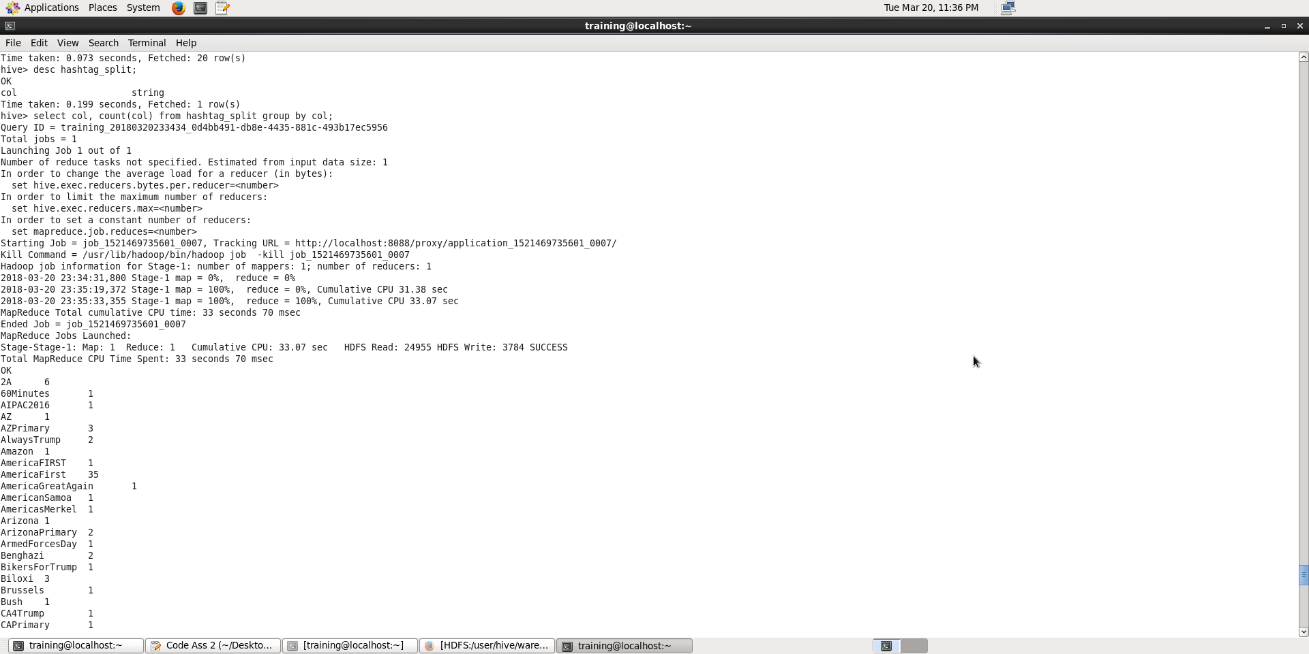

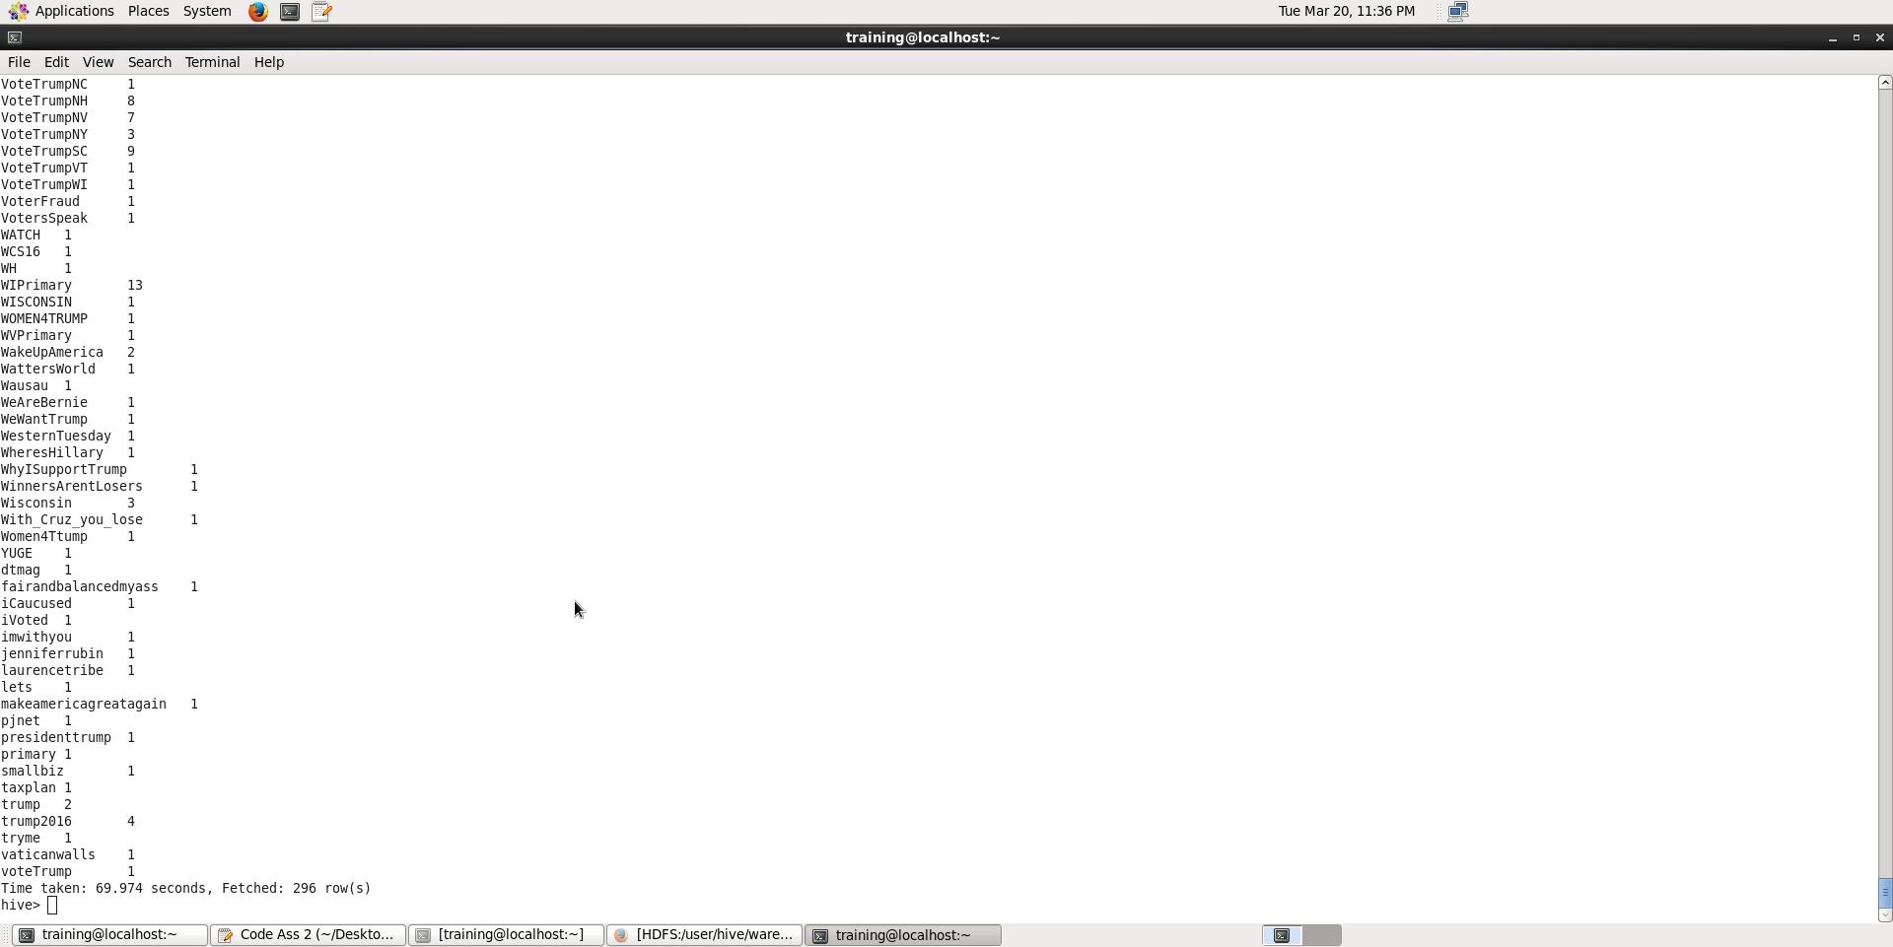

Ans: There are 296 unique hastags

B. select d.user.location, count(d.id) from tweet_json d where d.user.location in (select b.loc as loc1 from (select a.user.location as loc,count(a.user.id) as count1 from tweet_json a where a.user.id in (select t1.usr_id from (select user.id usr_id,count(id) count from tweet_json group by user.id order by user.id desc limit 25) t1) group by a.user.location order by count1 desc limit 1)b) group by d.user.location;

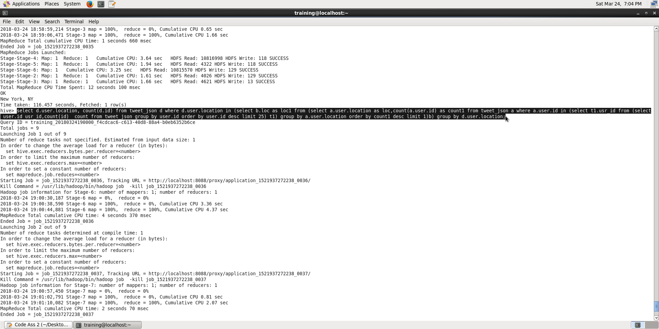

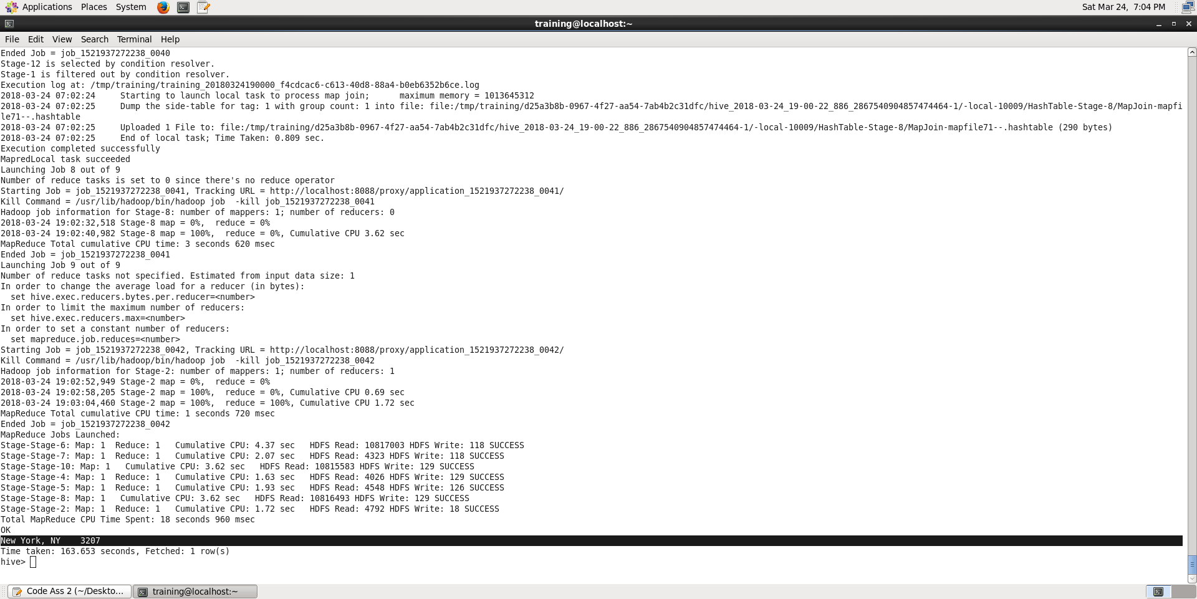

C. select user.id,user.name,MAX(user.followers_count) as count from tweet_json group by user.id,user.name order by count desc limit 10;

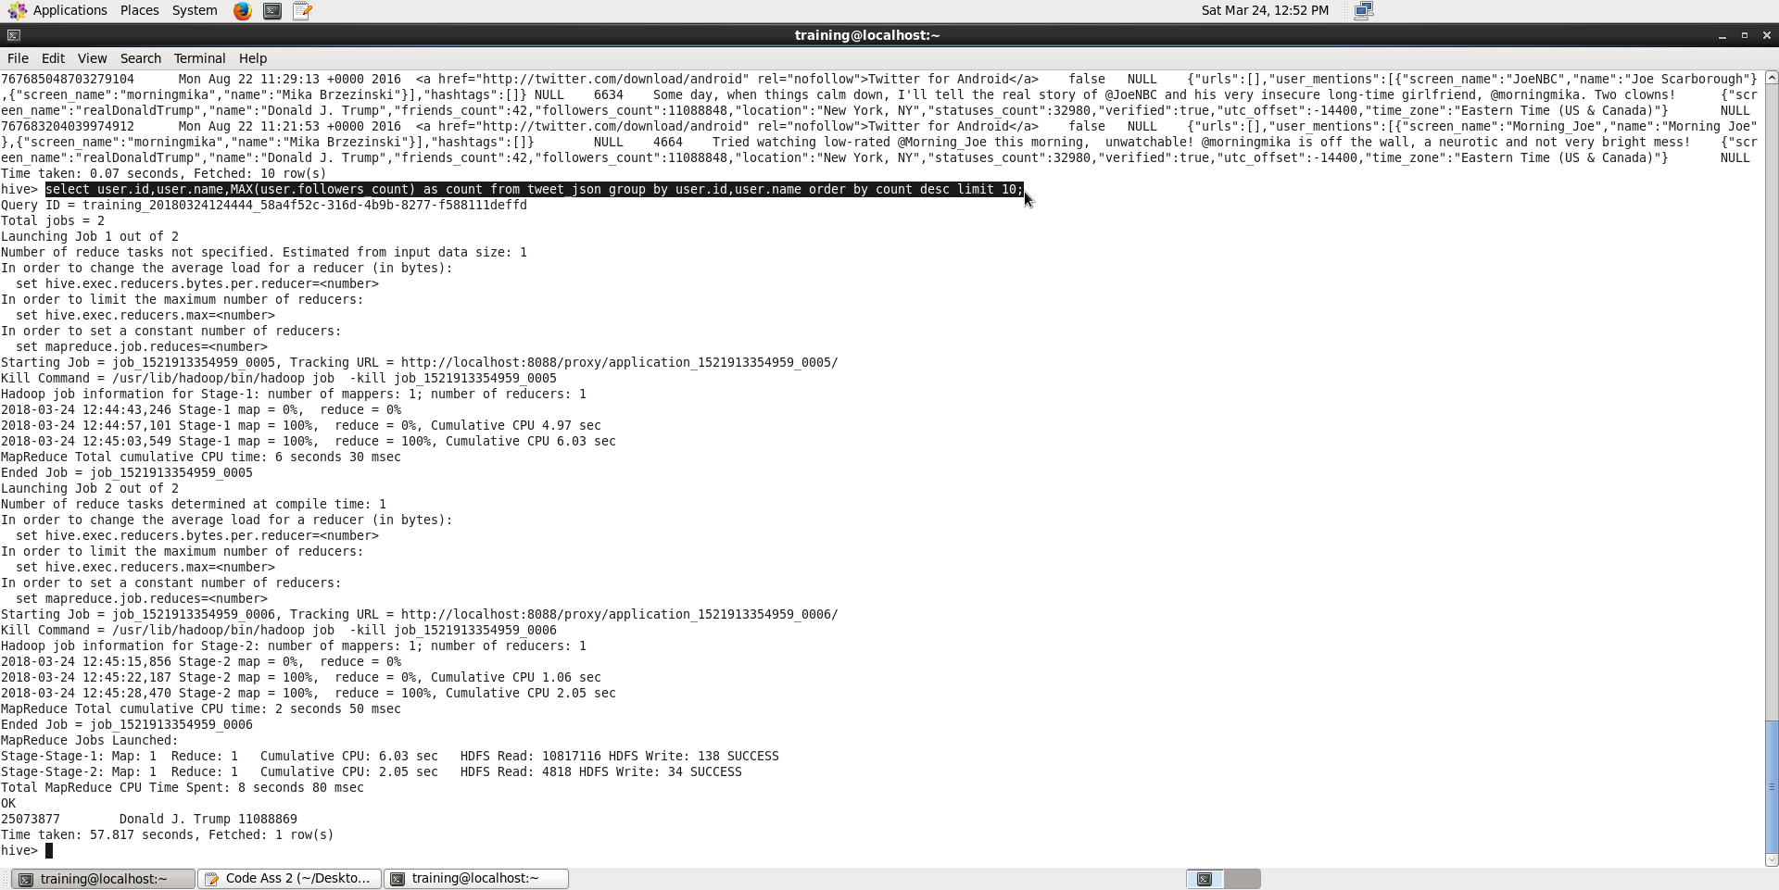

D. CREATE TABLE twitter_senti as SElect id as id,user.name as user_name,substring(CAST(from_unixtime(unix_timestamp(created_at,"EEE MMM dd HH:mm:ss zzz yyyy")) as STRING),1,10) ts,split( text,' ') as tweet from tweets_json;

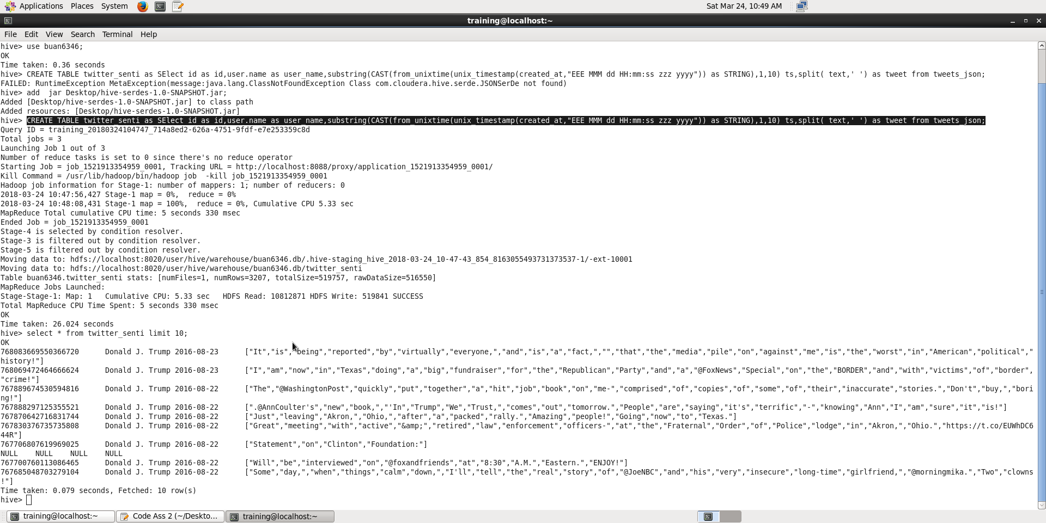

CREATE TABLE twitter_senti_split as SELECT id as id,user_name as user_name,ts as ts, tweets from twitter_senti LATERAL VIEW explode(tweet) t as tweets;

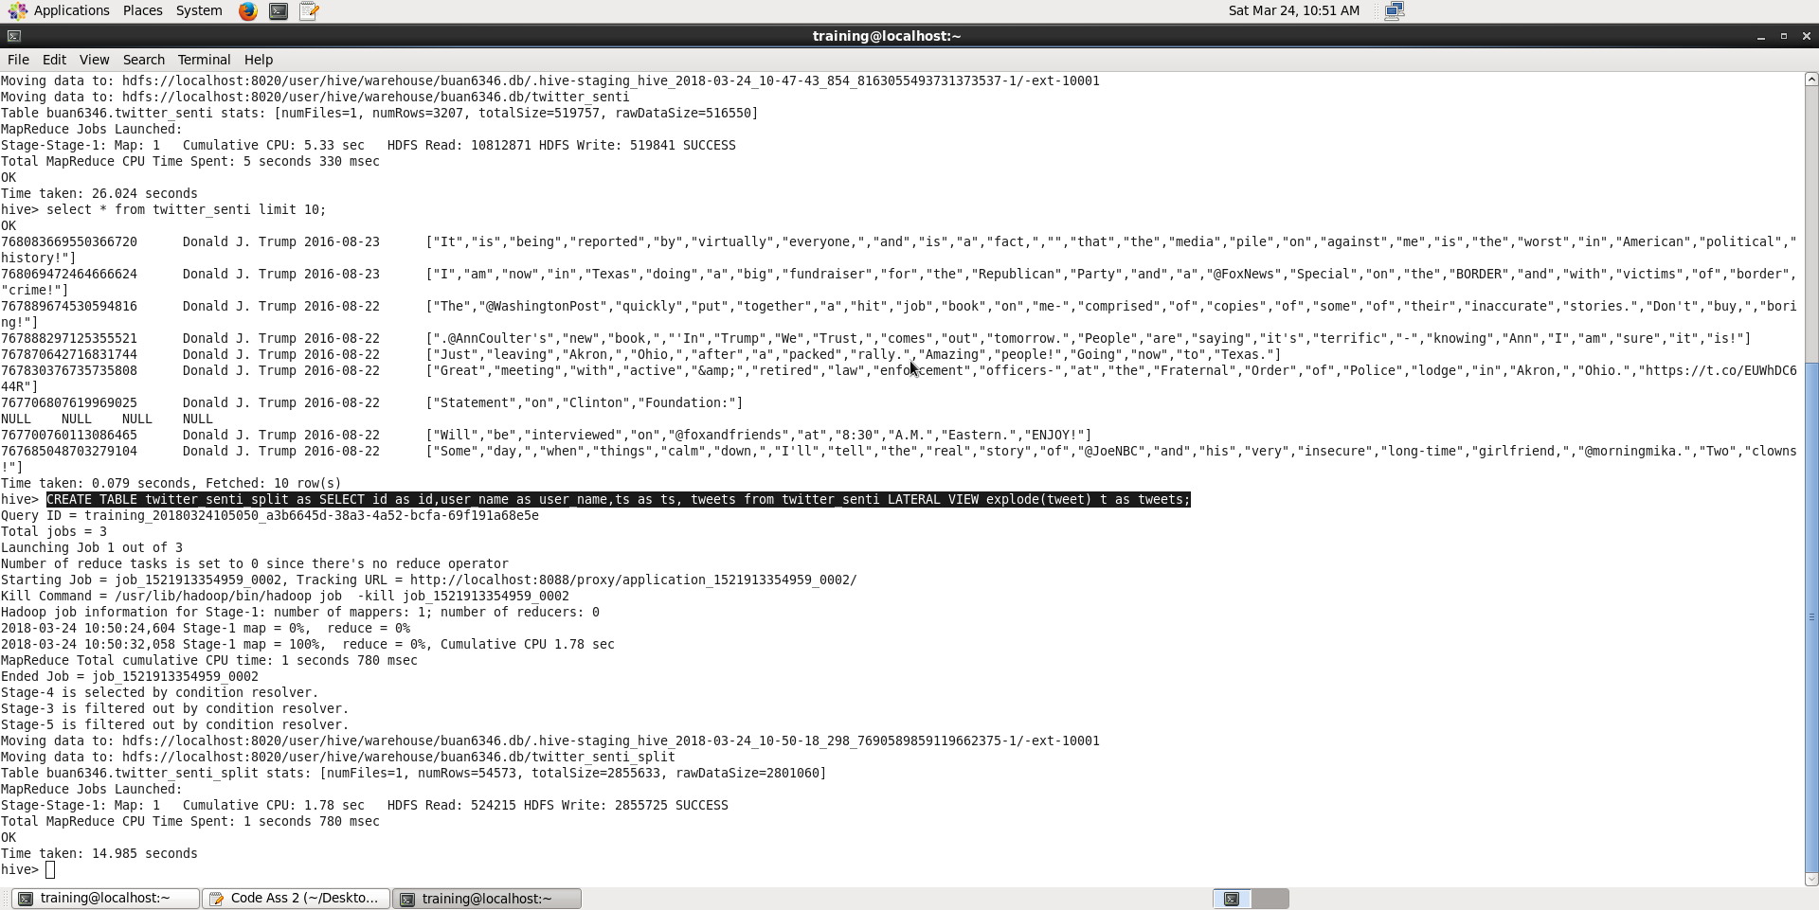

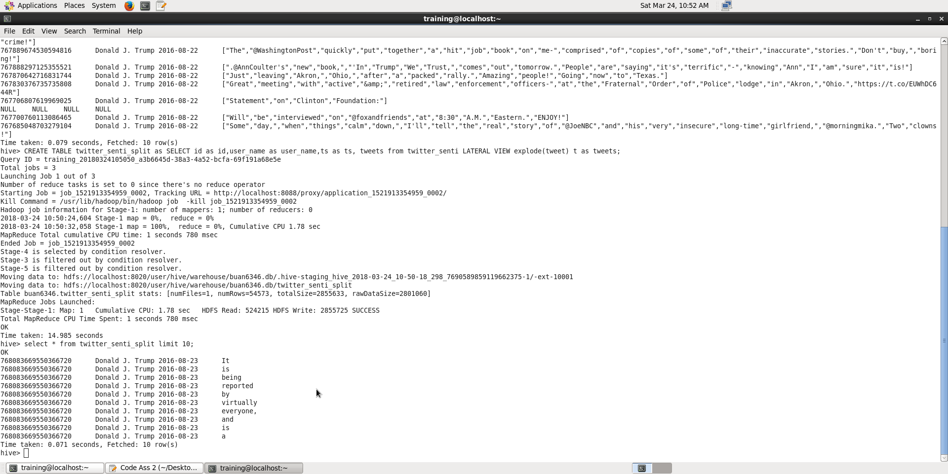

LOAD DATA LOCAL INPATH 'Desktop/Dictionary.txt' INTO TABLE dictionary;

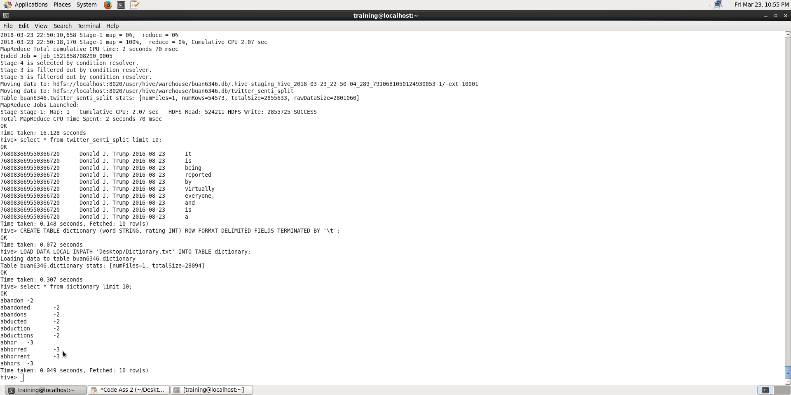

CREATE TABLE twitter_senti_rating as select id, user_name, ts, AVG(rating) as rating from twitter_senti_split JOIN dictionary on twitter_senti_split.tweets = dictionary.word group by id, user_name, ts;

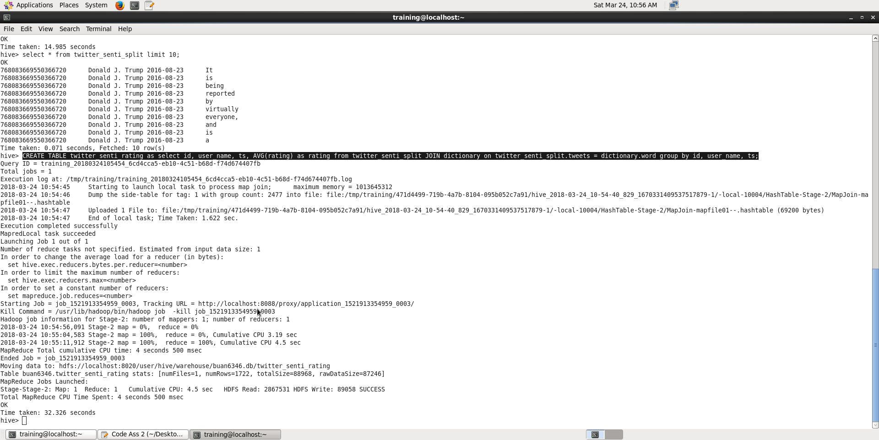

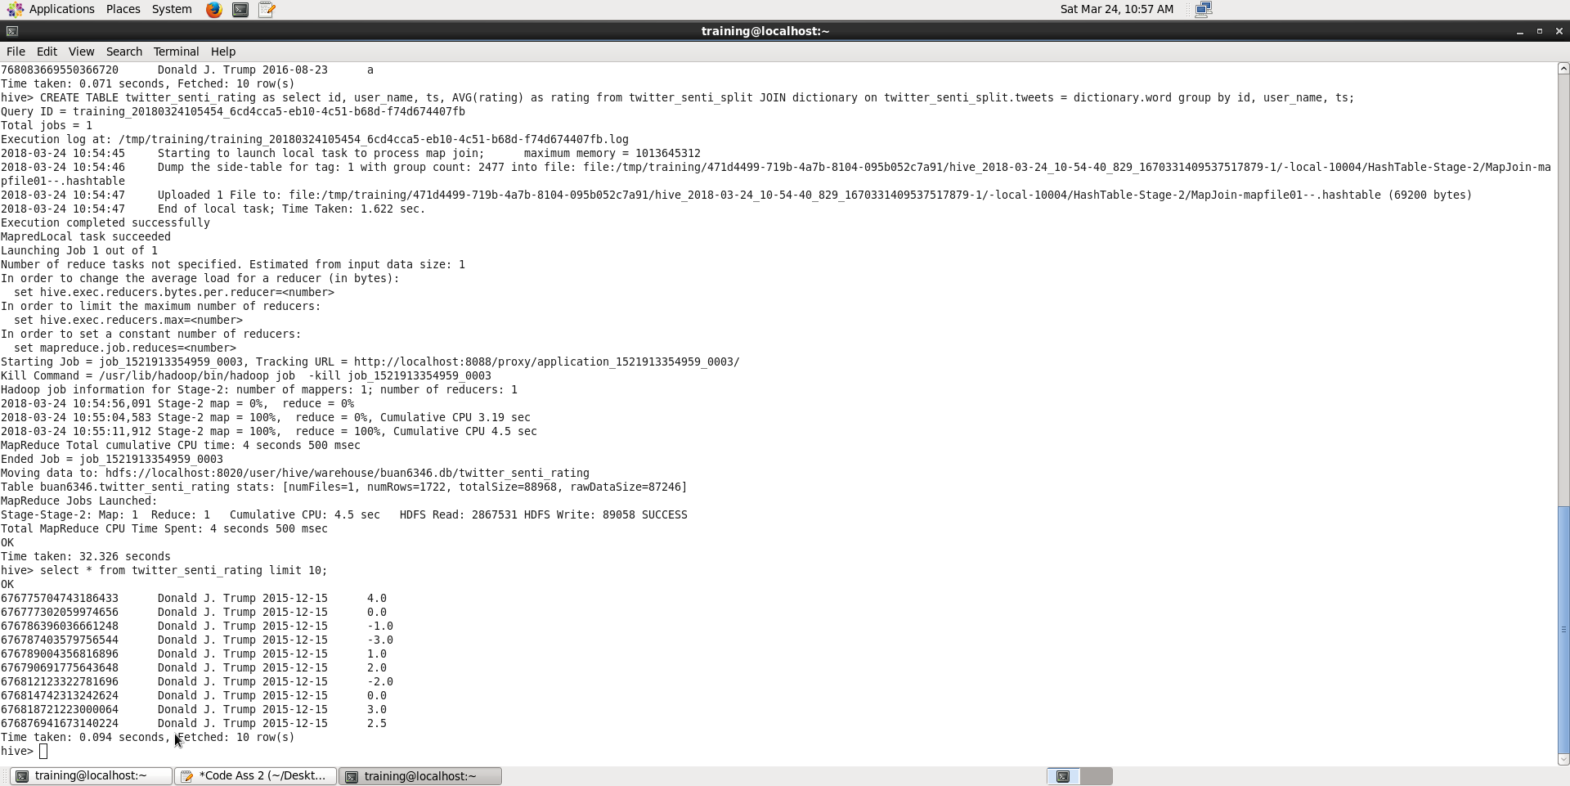

select id, user_name, ts, rating, CASE WHEN rating < 0 THEN 'Negative' ELSE 'Positive' END as sentiment from twitter_senti_rating;

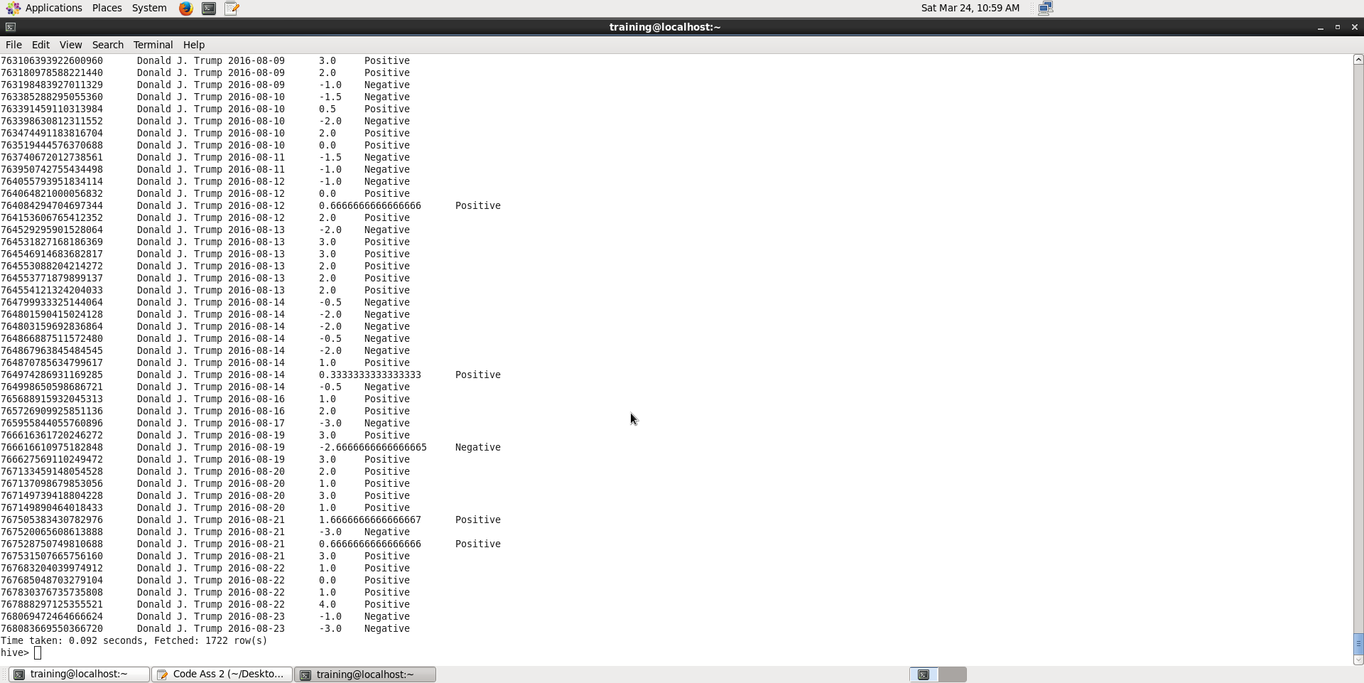

1. The sentimental analysis that was done in the previous question was based on the polarity value assigned to each of the words, if the sum is negative then the sentiment is negative and if the sum is positive the sentiment is positive. But, if we analyze the tweet contextually we can end up getting more insights and the exact sentiment.

So, my suggestion would be sentimental analysis based on the context. Ex. The food was not terrible is more like weak positive but the negative words not and terrible might make the entire more negative.